Vision and Scope Document

for

Unified Academic & Student Calendar System
Version 1.2 approved
Prepared by Group 18
LUT University
16.10.2026

Table of Contents
Table of Contents 1
Revision History 2
1. Business Requirements 3
1.1. Background 3
1.2. Business Opportunity 3
1.3. Business Objectives and Success Criteria 4
1.4. Customer or Market Needs 5
1.5. Business Risks 5
2. Vision of the Solution 6
2.1. Vision Statement 6
2.2. Major Features 6
2.3. Assumptions and Dependencies 7
3. Scope and Limitations 7
3.1. Scope of Initial Release 8
3.2. Scope of Subsequent Releases 8
3.3. Limitations and Exclusions 8
4. Business Context 9
4.1. Stakeholder Profiles 10
4.2. Project Priorities 10
4.3. Operating Environment 11
4.3.1 Accessibility and Availability 11
4.3.2 Supported Platforms 12
4.3.3 Data Sources 12
4.3.4 Access 12
4.3.5 Notifications 12
4.3.6 Data Protection and Privacy 12
5. Declaration of AI use 12

Revision History

Name | Date | Reason For Changes | Version
Group 18 | 29.09.2026 | Initial draft | 0.1
Group 18 | 04.10.2026 | Improving the content based on received feedback | 0.2
Group 18 | 07.10.2026 | Version 1.0 complete | 1.0
Group 18 | 12.10.2026 | Moving figure 1, and 2 to the appendix | 1.1
Group 18 | 16.10.2026 | Added MF10 Language Selection | 1.2

Business Requirements
At LUT University, students are missing deadlines for assignments, lectures, and other events due to fragmented schedules and the lack of unified ways to organize timetables, academic lectures, and events. The view with events and schedules will help the students manage their school experience and connect to the community. This enables students to allocate time for interesting events. Organizers will be able to save workload off organizing the event and money and avoid having events with too little attendees. The main reason to create an integrated view for LUT events and schedules is to save time, prevent confusion, and ease access to information.

Background
LUT is a university with a rich history in teaching technology, business, and social sciences. It has operated since 1969 and has various campuses in different locations. Due to different locations of the campuses, students´ schedules, events and deadlines are published on different channels which causes frustration, lost opportunities, missing deadlines etc. Often people are missing events as they are not aware of them due to fragmentation of communication channels and need of checking different channels. There are several different applications where these schedules for lectures and events are located like Tuudo, Moodle, Sisu, Instagram, Telegram, etc. This leads to confusion and makes time management difficult.

Business Opportunity
The main problem of this project (Appendix 1) is the fragmentation of information about schedules, events, and deadlines through different channels. This lack of communication often ends with students being confused and lost. Learning about students' community events might be too complicated due to the constant need to check different applications.

Created problem tree is showcasing causes, main problems and effects. Scattered information, hard user interfaces, different channels and applications, and even language barriers are different causes of the main problem. The upper part of the tree represents the effects and consequences. Students spend too much time scheduling, and they still miss deadlines, lectures, or events. For instance, Tuudo shows lecture schedules, Kide shows students and other events, and Moodle shows assignment deadlines. All of this should be combined into one unified view or place, which will save time and effort from searching and scheduling for all these different events.

Business Objectives and Success Criteria
Main goal of the project is to create one unified channel or view where scheduled events and assignments can be published and viewed easily to improve communication in LUT. The lowest level of the tree (Appendix 2) describes the main outputs or means which are necessary to happen to get to the main objectives. The solution needs to be easy to use, with a user interface that is not complicated. It should showcase events, lectures, and tutorials in a way that it is clear what type of classes are in Lahti, Lappeenranta, or Online. The notifications about the events, deadlines, and classes should be customizable. Different filters should be applied for event search.

Long lasting effects and how we are planning to measure them are described in Table 1. There are 6 main outcomes, which are possible to measure in qualitative and quantitative ways using surveys, observations, and interviews.

Business Objective ID | Objective | Action | Outcome
BO1 | Reducing the time for searching different events and reducing the information overload | Survey | Reducing the loss of resources and money for creating events that no one attends.
BO2 | Increasing student engagement and building strong and vital community | Number of people attending to the events | Strong community makes the students feel welcomed and valued, which results with lowering the cost of mental health risks and consultations. Higher attendance helps with finding friends and reducing the feeling of loneliness.
BO3 | Prevention of forgetting the events by sending meaningful notifications. | Survey | Students are more aware of what is happening on campus.
BO4 | Higher attendance rate especially at the beginning of the semester | Survey with teachers and students | Lowering the cost of education.
BO5 | Improving satisfaction of using school tools for scheduling | Survey | Faster and easier planning and scheduling.
BO6 | Better results of education and avoiding miscommunication in due dates of assignments. | Survey of teachers and students. | Saving the time of the teacher and lowering the stress levels for students.

Table 1. Business objectives with actions and outcomes to measure success.

Customer or Market Needs
The users of this system are going to be mainly LUT students. The main causes of the problem are shown in the problem tree (Appendix 1) and are divided into two main categories: missed academic events and missed academic deadlines. Both of those categories might have different impacts on the user. The effects of missing lectures, or deadlines for assignments can directly influence the educational outcome of the student, while event part, connected with social part of the life and building the community might change the overall perception of studying. There is a need for a reliable notification system with deadlines and events. Navigating over Moodle, Teams, Sisu, Tuudo and many more is time consuming, stressful and frustrating. There is a need for a simple and easy to use solution, so that scheduling and planning will be easier and faster. Event organizers need to have a reasonable channel to inform all students about events to heighten the attendance rate and allocate funds and effort on meaningful events.

Business Risks
Risks in this new solution for unified views for schedules are potentially high cost. Costs would consist of acquiring a tool that will fetch information and combine it with other schedules. If the third-party tool of this kind is acquired, there will be a high possibility that even small updates of layout in any of the existing calendars, or app, our solution will stop working. The scrapers are often blocked by companies like Meta and might not work as designed. Upkeep and maintenance are also resource-consuming factors. There is also a risk of overloading the new view with a massive number of events and lectures. The view which was supposed to make planning and management of time easier now might get or remain as confusing as it has been before.

Vision of the Solution
This section presents the long-term vision for the Unified Academic & Student Calendar System, based on the goals and priorities confirmed by Group 20.

Vision Statement
For LUT University students and teaching staff who need one reliable place to see their academic and student life events instead of checking multiple separate platforms, the Unified Academic & Student Calendar System is a web application that automatically brings together academic events, social events, personal events and reminders into a single unified view. Unlike existing individual university systems and generic calendar apps such as Google and Apple Calendars, which require manual importing and miss LUT specific events, our product pulls data directly from LUT’s existing systems, giving every student and staff member a fast and error free overview of their academic and student life.

Major Features

Major Feature ID | Feature Name | Description
MF1 | Unified View | Users can access schedules, events and assignments in one unified channel or view
MF2 | Academic Events View | System automatically retrieves lecture schedules, assignment deadlines and event dates from Sisu, Moodle, and TimeEdit through their APIs
MF3 | Social Events Web Scraper Bot | A web scraper bot automatically collects social events information from Kide, Instagram and Telegram
MF4 | Personal Events | Users can create, edit and categorize personal events and manage notifications
MF5 | Manual Event Creation | Users with privileges can manually create events (lectures, social events) and select a target audience for them
MF6 | Push Notifications | System automatically pushes notifications about upcoming events and deadlines
MF7 | Export & Synchronization | Users can export and synchronize with external tools such as Google Calendar, Apple Calendar or Outlook
MF8 | Login Integration | Users must log in with personal university account without additional registration
MF9 | Public API | API that allows external developers to connect to the system
MF10 | Language Selection | Users can change the language of the user interface between English, Finnish and Swedish

Assumptions and Dependencies

Assumptions:

- Sisu, Moodle and TimeEdit will continue to provide stable and accessible APIs that the system can pull data from automatically.
- TimeEdit remains the main source of truth whenever scheduling data conflicts between systems.
- Student unions will not need to change their existing event publishing tools such as Kide or social media. The system adapts to pull from these sources.
- Users already have valid LUT University credentials used for login.

Dependencies:

- Continued API access to Sisu, Moodle and TimeEdit for automatic academic data collection.
- LUT IT services for hosting, infrastructure, and integration with the university’s authentication system.
- Access to student union event sources such as Kide, Instagram, Telegram or other channels that may require web scraping for the student life feature.
- Approval of the project budget of approximately € 200 000, with a maximum budget of €500 000 to fund the development of the API integrations and any required scraping tools.

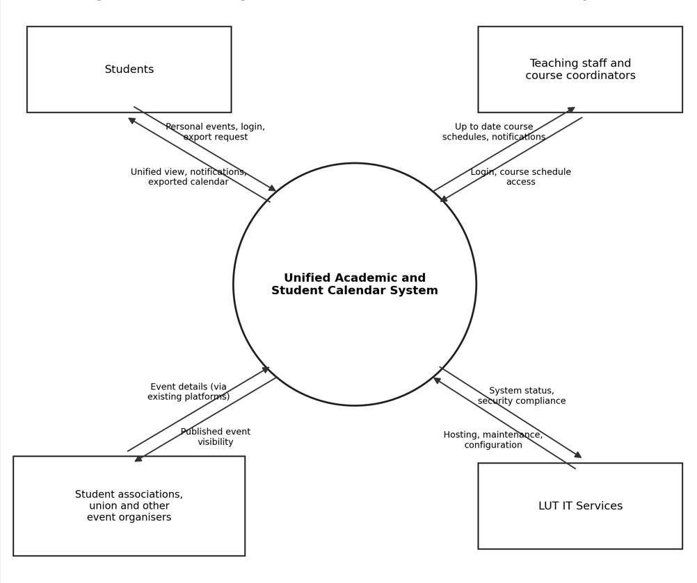
Figure 1. Context Diagram for Unified Academic & Student Calendar System

Scope and Limitations
This section outlines the planned release schedule for the system based on Group 20's priorities. The development focuses on the unified view capabilities first, followed by personal and social event features, and concludes with supporting tools. This follows the idea that students would benefit the most from accurate information on academic deadlines, as shown in Appendix 1.

Scope of Initial Release
Initial release of the software will take place in Q1 2027. It will be a web page featuring core unified view functionality. The priorities are on BO1, BO3, BO4, and BO5 with emphasis of reliability for accurate schedule display and seamless integration with existing systems. The following major features will be included:
- Unified View (MF1)
- Academic Event View (MF2)
- Export & Synchronization (MF7)
- Login Integration (MF8)

Scope of Subsequent Releases
The second release will take place in Q2 2027. It will focus on the personal view functionality with an emphasis on usability and personalization. It is related to BO2 and BO5, and includes the following features:
- Social Events Web Scraper (MF3)
- Personal Events (MF4)
- Manual Event Creation (MF5)
- Push Notifications (MF6)
- Language Selection (MF10)

The final release will take place in Q3 2027. It prioritizes portability and extensibility to allow third-party integrations, further expanding on BO5. The release will include a mobile release and support for external developers. The following major feature will be included:
- Public API (MF9)

Limitations and Exclusions
Limitation ID | Limitation Name | Description
L01 | Communication mechanisms | The system will not implement any communication mechanisms.
L02 | Sharing functionality | Users will not have the ability to share their personal events.
L03 | Support for other schools | Schools other than LUT University are excluded, so language courses offered by LAB will not be integrated.

Business Context
This section identifies the key stakeholders for the Unified Academic & Student Calendar System, the project’s priorities, and outlines the environment and conditions in which the application must run.

Stakeholder Profiles
External university students and entities are not included as stakeholders.

Stakeholder | Major Value | Attitudes | Major Interests | Constraints
Students | A unified view of all courses, assignment, and events. | Highly receptive, but expect accurate and reliable, up-to-date information on events. | Course calendar, assignments and deadlines, personal events. | May be hesitant to use another platform and have limited time to adapt to the new platform.
Teaching staff and course coordinators | Better student engagement and performance | Indifferent since they are not required to upload or update information in a new location. | Events are pulled automatically from existing platforms. | No direct entry; events pulled from existing platforms, so event visibility depends on the reliability of web scrapers.
Student unions and event organizers | Better event visibility, and better student engagement | Highly receptive. | Their events are shown automatically without having to enter them to a new location. | No direct entry; events pulled from existing platforms
LUT IT Services | A new quality-of-life improvement for students. | Supportive, but the application must adhere to their regulations. | Hosting and ensuring LUT standards are implemented. | Budget of at most €500,000

Project Priorities
Dimension | Driver  (state objective) | Constraint  (state limits) | Degree of Freedom  (state allowable range)
Schedule | Release 1.0 must be delivered before the next academic year. | Must meet the delivery deadline. | Release 1.0 can be released in beta state.
Features | Web application, courses, assignments and deadlines, and events calendar. | The Web application, courses, assignments, and deadlines calendar are core features that must be included in version 1.0. | Secondary features like the consolidated events calendar can be added in a future update.
Quality | At least 90% satisfaction rate from focus group test users. | Must maintain good performance and responsiveness on all web platforms and screen sizes, and always remain synchronized with data sources. | Bug fixes and non-critical updates can be done after the release.
Staff | A 6-person team consisting of a Project Manager, 2 developers, 1 designer, and 2 Q & A engineers. | Limited time, size, and experience. | Roles and tasks can be shared as needed.
Cost | Total project cost of €200,000 | Budget limitations are tied to the LUT IT Department. | Can reach a maximum of €500,000.

Operating Environment
The Unified Academic & Student Calendar application will be primarily used by students of LUT University. The application will be hosted on LUT servers and will require signing in with an LUT account. Moreover, its UI must be responsive across all browsers and screen sizes.

Accessibility and Availability
- The system must be available 24/7 with a maximum of 48 hours of downtime in a year.
- Downtimes will be communicated through alerts and notifications withing the application itself.
- The system must be accessible from external networks outside of the LUT campus.
- Content and information must be synchronized with other calendar sources and websites, including but not limited to Tuudo, TimeEdit, Sisu, Moodle, and student unions’ and student associations’ Telegram channels.

Supported Platforms
The release 1.0 of The Unified Academic & Student Calendar application must be supported on all web browsers and screen sizes. A mobile application version of the application may be developed in the future, but it is not a priority.

Data Sources
The Unified Academic & Student Calendar application does not require, nor allow, direct entry of data and events, except for personal events. The application must consolidate all events and calendars through the use of dedicated APIs and web scrapers. Data sources include:
- TimeEdit.
- Sisu.
- Moodle.
- Tuudo.
- Student union and student association Telegram channels.
- Student union and student association WhatsApp channels.
- Addition of personal events.

Access
Users are required to login using their existing LUT accounts. There will be higher privileged accounts that can update the publicly viewable content.

Notifications
The application will not employ the use of emails for sending notifications. All notifications and alerts will be communicated through the platform itself.

Data Protection and Privacy
The Unified Academic & Student Calendar application will be hosted on LUT IT infrastructure and will inherit security standards and regulations enforced by LUT. Moreover, personal events added to the view will not be shared with other users and will only be privately visible. Furthermore, notifications and alerts will only be communicated within the application and will not make use of the user’s email address for communication purposes.

Declaration of AI use
For that assignment, ChatGPT (https://chatgpt.com/) was used for supplementary reading and research, and the same LLM was also utilised for linguistic purposes to enhance the text readability.

APPENDIX 1

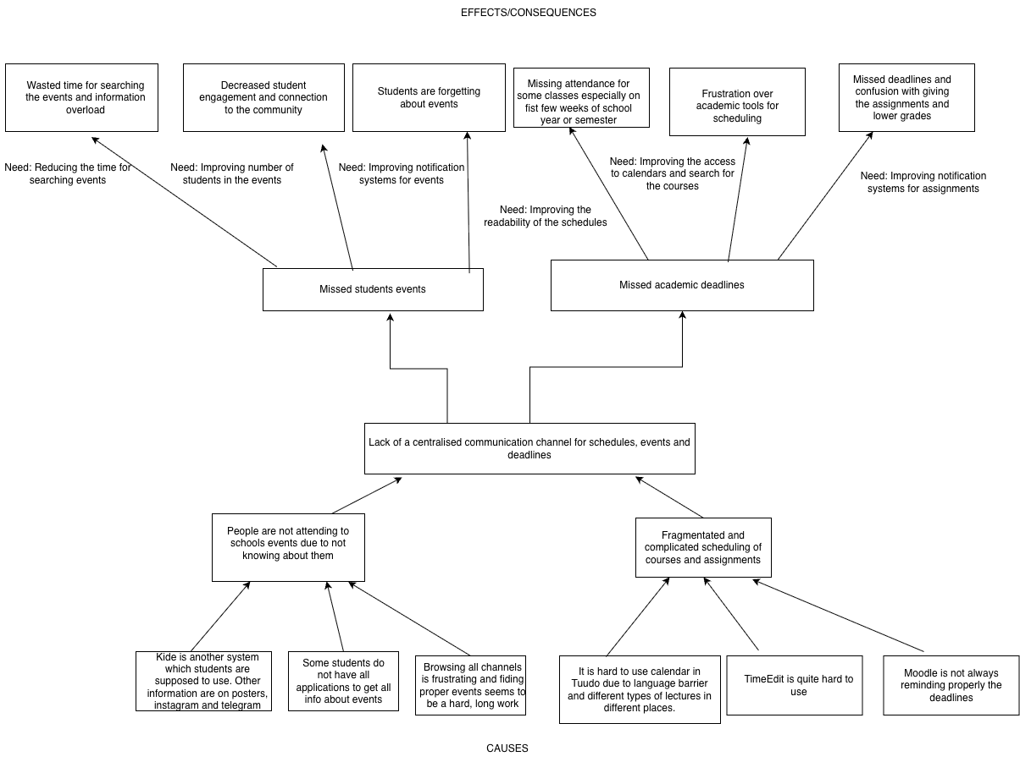
Problem tree

Appendix 2

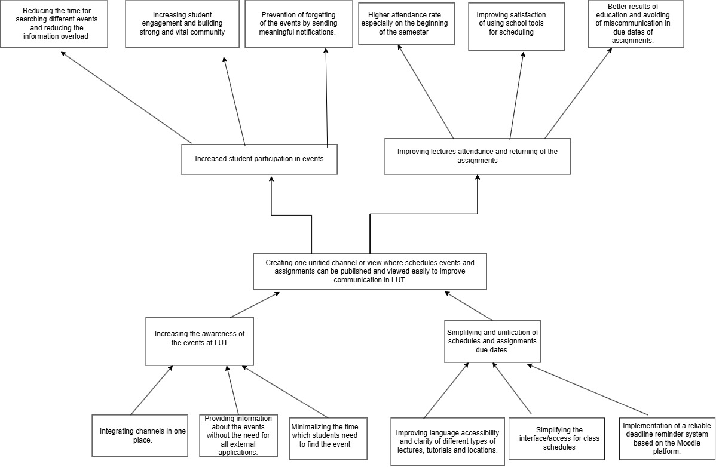
Goal tree

